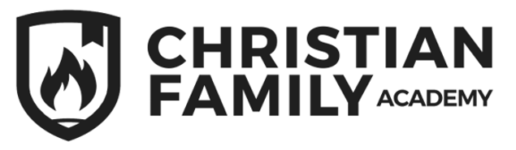
`
PRESCHOOL SUPPLY LIST

Backpack-big enough to hold 8”X 11” folder
Lunchbox
Spill-proof water bottle
Change of clothes in a Ziploc bag labeled with child’s name
3-year-olds Only- 2 packs of 8 Jumbo crayons
4-year-olds Only- child size scissors, 1 pack of 24 crayons

Label everything with child’s name.

